第六章 GRASP：从职责出发设计对象习题

Consider an application at Larnharm Goode, Inc., a small seminar company. The company offers a seminar each week. A customer can make a reservation for a given seminar, with or without a deposit. A deposit entitles the customers to a firm reservation; without it, the customer gets only a tentative reservation. A tentative reservation can be canceled at any time. But the customer can not cancel a firm reservation. For some weeks are more in demand than others, the company establishes the concept of peak (highly popular) weeks. Only firm reservations are allowed for the seminar in peak weeks.
1. Draw a class diagram for the application.
2. Draw sequence diagrams for making a reservation a given seminar.

答案
1、
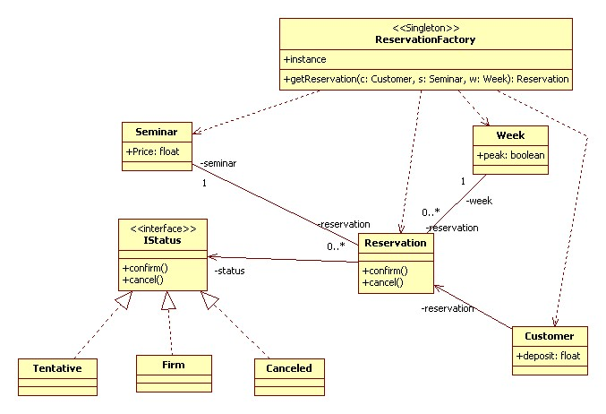
2、
